Role of Agricultural Counselling Centre in the Development of Black Rice Programmeme in Ctral Java, Indonesia
https://dx.doi.org/10.4314/jae.v23i3.7

Zulfiningrum, Rahmawati
Department of Communication Science, Faculty of Computer Science, Dian Nuswantoro University, Jl. Imam Bonjol No. 207, Semarang 50131, Central Java, Indonesia
Corresponding author: darumzulfie@gmail.com, Phone: +62-82299984192

Sumardjo, Sumardjo
Department of Communication Science and Community Development, Faculty of Human Ecology, Bogor Agricultural University, Dramaga, Bogor 16680, West Java, Indonesia. Email: sumardjo252@gmail.com, Phone: +62-8129054519

Saleh, Amiruddin
Department of Communication Science and Community Development, Faculty of Human Ecology, Bogor Agricultural University, Dramaga, Bogor 16680, West Java, Indonesia. Email: amiruddin_ipb@yahoo.co.id, Phone: +62-811119279
Agusta, Ivanovich
Department of Communication Science and Community Development, Faculty of Human Ecology, Bogor Agricultural University, Dramaga, Bogor 16680, West Java, Indonesia. Email: iagusta1970@gmail.com, Phone: +62-81218806075

me in C

Abstract
The study assessed the role of agricultural counselling centres in the development of black rice programmememe intral Java, Indonesia. Black rice is a food source that has health benefits. Purplish black colorcocomes from anthocyanin which contains high antioxidants, used as an alternative healthy food to prevent degenerative diseases such as heart attacks and diabetes. The purpose of the study was to analyze the convergence communication and communication networks of actors who are involved in the development of black rice programmeme. Phenomenoly and qualitative approaches are used to find out how the actors interact in the development of black rice programprogramhis study to data from in-depth interviews with 32 informants, 19 FGD informants, observation processes and analyszed using UCINET 6 The results show that communication networks are formed in personal networks, the highest degree of centrality value was used to see the interaction between actors with the link in the meeting of information needs (0.287). The actors who have the highest centrality value, the Agricultural CounselingCounsellCentre (BPP)ates that BPP has the ability to be a communication bridge in the communication networks to increase the participation of actors in the development of black rice programprogrammemeer to runustainable.
Keywords: Black rice, communication networks, convergence communication, programmeme devepment.

Introduction
It is increasingly recognized that many health problems are due to food factors, such that cause various diseases such as diabetes, cholesterol, and heart attacks. Black rice has a low calorie level compared to white rice and brown rice. Its high anthocyanin content is located in the pericarp layer, which gives a dark purple colour. Anthocyanin has been recognized as a functional healthy food ingredient due to its antioxidant activity (Shin, Kim, Lee and Lim, 2019). Black rice also have anti-cancer, hypoglycemia and anti-inflammatory effects (Alves, Ferreira, Vivian, Monks, Elias, Vanier and de Oliveira, 2016). The anthocyanin pigment is effective in reducing cholesterol levels, preventing the risk of heart attack because of its high fiber, prevent anemia because it contains iron, prevents premature aging, and has higher protein, vitamins and minerals (Joo and Choi, 2012; Bae and Chung, 2015; Shao, Hu, Yu, Mou, Zhu and Beta, 2018). Black rice is an alternative to white rice substitutes and has a low glycemic index with IG value of 42.3. Consuming black rice regularly could be an alternative solution for maintaining health (Hwang, Kim, Bhulyan, Kim, Yang, Yoon, Yoon and Kim, 2018). So far black rice also has high economic value because it sales value is above other rice (Pratiwi and Purwestri, 2017). Therefore, if cultivated optimally it can improve the welfare of farmers.
Sirampog is a sub-district located in the mountainous area of Brebes District and a centre for producing vegetables. The community rediscovered the black rice seeds of their ancestors which were planted for generations and began to develop them. Often, there is a confusion in the community and think that the black rice is black sticky rice, the impact is that the community does not know the differences and benefits. Black rice is very different when compared to black sticky rice or white rice, in terms of taste, the aroma and appearance are very specific and unique (Meng, Zhang, Wu, Hui, Gao, Chen and He, 2018). It has hard stems, with twice the height of ordinary rice around 170-210 cm. The grain shape is round shiny, and the colour is purplish black. If it is exposed to the water the colour of black rice directly out, so it can be consumed as a healthy drink or black rice drink.
Black rice farming is one of the leading commodities in accordance with the Regional Regulation of Brebes District Number 09 of 2014 concerning the Regional Budget of the Brebes Regency Budget Year 2015. Concerning the determination of implementation team of black rice development programme in the extension activities for alternative food sources in Brebes District 2015 (Department of Agriculture and Food Security, 2015) of the alternative food source extension of Brebes district in 2015. The regional government through the Office of Agriculture and Food Security conducted guidance on seven black rice village centres, including the expansion of black rice land.
The research focused on the development of the potential black rice in Sirampog sub-district, Brebes District. The purpose of the research was to analyse convergence communication in order to form effective communication strategies in developing black rice programmememes.

Methodology
The research location was in the Brebes District, Central Java Province, Indonesia which is located at 6º44’21 South Latitude and between 108 º 41’11 East Longitude. It was conducted in seven villages that developed black rice farming Kaligiri, Sridadi, Mendala, Mlayang, Manggis, Kaliloka, and Plompong in Sirampog sub-district, Brebes District. The study was conducted from September 2017 to December 2018. There were 32 informants in in-depth interviews, nine (9) informants in the Sirampog FGD, and ten (10) informants in the Brebes FGD.
The study used a qualitative approach to the constructivism paradigm. According to Lewis (2015) the constructivism paradigm suggests that knowledge is obtained when researchers are able to understand the perspective of the informant. A qualitative approach with phenomenological methods was applied to build an understanding of the development of black rice programmemes bason the perspective of the actors who were involved.
The analysis of the communication network applied was degree of centrality using the UCINET 6 version 6.627 software by making a communication relationship matrix from the results of the sociometry statement. Matrix making based on in-depth interview data, consists of lines that present the source of the relationship and the column that presents the target. Communication relations are marked with a number, if there is a relationship, the number symbol is written 1, and if there is no relationship or interaction between actors or nodes the number symbol is 0 (Eriyanto, 2014). Interaction data is made in the form of sociograms to describe the structure, relationship patterns, roles, and figures in communication networks to design effective communication strategies.

Results and Discussion

Communication Network Analysis in the Black Rice Development Programmeme
A network in the concept of sociology is a type of relationship between actors characterized by symmetrical forms of reciprocal interaction. Every relationship between actors that are interwoven in society is a form of network, if the basis of social relations is different, it will produce different networks. The fabric of social relations, each actor carries his own personality traits, therefore, the configuration of the entry or exit of an actor in the fabric of social relations will influence the creation of an interaction structure (Manson, Jordan, Nelson and Brummel, 2016). Social networks can be used by actors to share information, expand networks, and form networks that influence each other (Zulfiningrum and Yusriana, 2018).
Network communication is a network consisting of actors that are interconnected and connected by a communication process that has a pattern. The structure of communication can be seen through the analysis of communication networks (Patterson, Pfeiffer, Weaver, Krackhardt, Arnold, Yealy and Lave, 2013). In the development of black rice programmeme the alysis of communication networks is used to see the interaction between actors with the link in meeting information needs and analyzing the degree of centrality. The detailed coding or distribution of node codes is shown in Table1.
Table 1: The role distribution of nodes on the development of black rice programmeme
The Role of Node | Number of Node | Node Code
Farmer | 34 | 11, 12, 20, 21, 22, 23, 25, 26, 27, 29, 31, 34, 35, 36, 37, 38, 39, 40, 41, 42, 43, 44, 45, 56, 63, 71, 72, 74, 75, 77, 79, 80, 81, 82
PPL (Field Agriculture Extension) | 6 | 24, 28, 30, 32, 33, 61
BPP (Agricultural Counselling Centre) | 3 | 9, 14, 62
Gapoktan (Farmer Group) | 2 | 15, 70
Sorting Personnel | 1 | 13
Traders | 2 | 10, 16,
Consumer | 1 | 18
Department of Agriculture | 10 | 4, 5, 6, 46, 50, 55, 57, 59, 60, 69
Local Government | 4 | 8, 47, 58, 65
Baperlitbangda | 5 | 1, 2, 3, 7, 67
Head of sub-district | 1 | 17
Village Head | 3 | 19, 76, 78
Government Tourism Office | 1 | 51
Disperinaker (Department of Industry and Labor) | 1 | 52
Cooperative Office | 1 | 64
BPTP (Institute for Agricultural Technology Studies) | 1 | 48
Balitsa (Plant & Vegetable Center) | 1 | 49
Central Governmenr | 1 | 53
SUCOFINDO | 1 | 54
Investor | 1 | 66
Ministry of Agriculture | 1 | 68
Governor | 1 | 73

Measurement indicators for networks include: 1) connectedness, 2) reachability, 3) reciprocity, (4) density, 5) centrality, and 6) betweeness (Williams & Musolesi, 2016). The process of interpersonal communication can be described through communication networks, so that it can be seen who is the opinion leader or follower who has a communication relationship related to a topic in a social system such as a village, organization or company. Analysis of communication networks describes who are the actors involved in delivering information, distributing information to each node (actor) and how the process of network formation (Patterson et al., 2013). Research uses the fifth measurement degree of centrality to see the interactions that occur between actors with their links in meeting information needs, and their figures on the development of black rice programmeme.
The communication network analysis of the research carried out, and the actors in the development of black rice programmeme incled farmers, PPL (Field Extension Officer, Agricultural Counselling Centre (BPP), Gapoktan, sorting personnel, traders, consumers, agriculture service, local governmeent, Baperlitbangda, head of sub-district, head of village and other actors related to development programmeme with a totaof 82 people. Actors were given codes in the form of numbers to facilitate the data management, each code shows the number of actors who are involved in the communication network system. Startingtartingumber one to number 82 before conducting sociogram analysis. The result of degree centrality in communication networks is shown in Table 2.
Table 2: Degree of centrality in communication networks in the development of black rice programmemes bason normalized values.
Actor | Score | Role
Actor number 14 | 0.287 | Head of BPP and PPL
Actor number 9 | 0.225 | PPL
Actor number 5 | 0.213 | KJF Extension Agent Department of Agriculture
Actor number 15 | 0.188 | Head of Gapoktan
Actor number 25 | 0.175 | Farmer
Actor number 24 | 0.050 | PPL

The sociogram of the development of black rice programmeme showthe number of actors and their dominance in the dissemination of information. Network analysis reveals how people in organizations interact with each other in groups, one type of group is called clique, a group of individuals that are interconnected (Toral-Cruz, Mihovska, Gaj, He, Ramirez-Pacheco, Voznak and Lokshina, 2017). Convergence model of communications proposed can be implemented effectively and efficiently in the context of agricultural extension and agricultural development. Convergent communication approaches are based on reciprocal or relational communication processes with emphasis on information. The communication convergence model applies the retrospective concept (reviewing as a reference for future strategic planning) in achieving mutual understanding.
The established communication network is a personal network. The opinion leaders, have an influence and interact with many other members), and are owned by actor number 14 with the highest centrality value of (0.287), the head of the BPP (Agricultural Counselling Centre) as well as the Field Extension Officer, (PPL) Field Extension Officer who accompanied the development of the programme from the beginning to the present, so that it has considerable influence and interacts with many other members. Star, (the most known and most frequent communication network) owned by actor number 14, number 9 PPL (Field Extension Officer) programme development and marketing assistance with a value of centrality (0.225), and number 5. Extension Agent Department of Agriculture which assisted the development of the programme from the start with a value of centrality (0,213). Gate Keepers (controlling information flow among members of the organization) are owned by actor number 9 (ZUF), and liaison (the clique link but not the clique member that connects, has influence and organizational parts) is owned by actor number 24 (WRT) PPL in developing the programme with a value of centrality (0,050). The sociogram for the development of black rice programme is presented in Figure 1.
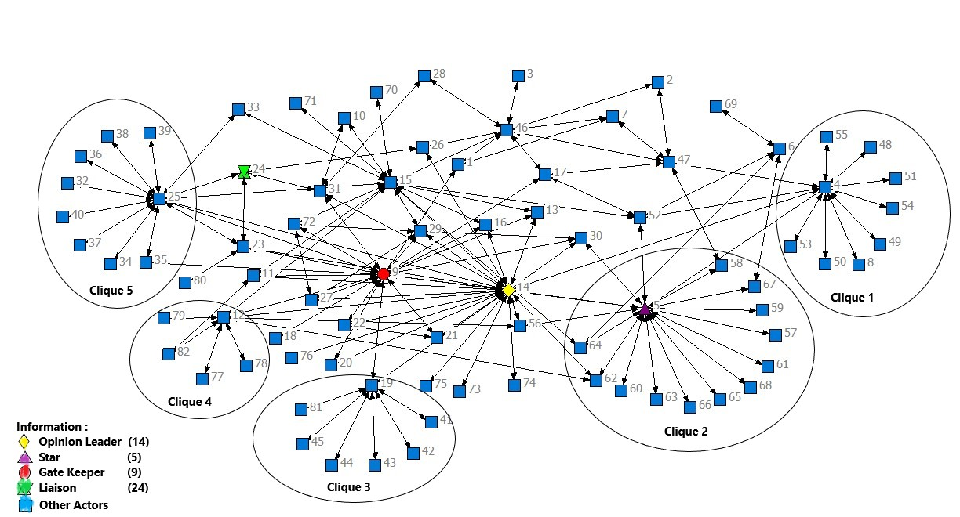
Figure 1 : Sociogram for the development of black rice programmeme
Collective action requires action from actors who are built on mutual agreement and understanding (Feiock , 2013; Patterson, 2017). When an actor believes that the same statement is something that has a strong reason, this can be realized through consensus or mutual agreement, which is the development of a sustainable black rice programmeme. Mutl understanding will lead to participatory communication as an effective communication strategy of programmeme to increasehe involvement of farmers in seven villages in the development of black rice programprogram
Judging from the results of the distribution of degree of centrality proven that actor number 14 represents the BPP as opinion leader has the highest centrality value. Actors as star and liaison are also PPLs (Field Extension Officer) from the Agricultural Counselling Centre (BPP) , even though there are stars representing the agriculture service. This indicates that in its role as an institution BPP has the ability to become a bridge of communication to increase the participation or involvement of all actors.

Convergence Communication in the Development of Black Rice rrogrammeme
Information shared by actors in the communication process for black rice development programmeme can ad to collective action, mutual agreements, and mutual understanding.
Interpretation and understanding of information has increased from individual processing information into a process of communication among actors who have shared goals (Aka, 2019). Programme information that is distributed by the Department of Agriculture in the communication process of black rice programme development requires the role of BPP or PPL as a communication bridge between the Department of Agriculture and farmers. Implementation for the farmers includes cognitive aspects, skills, and attitudes. Collective farmer actions are needed to achieve successful programme, increase in black rice productivity, increase farmers’ revenue, and expand the planting area. Dialogue is conducted to find out coherence among the actors. Divergence in programme development becomes convergence agreement among the farmers so that the programme development can be sustainable (Hayran, Gul and Saridas, 2018). Mutual agreement among the farmers so that the programme development can be sustainable, raises a mutual understanding among farmers that participatory communication is needed as a communication strategy therefore the development of black rice programme can be sustainable in Figure 2.
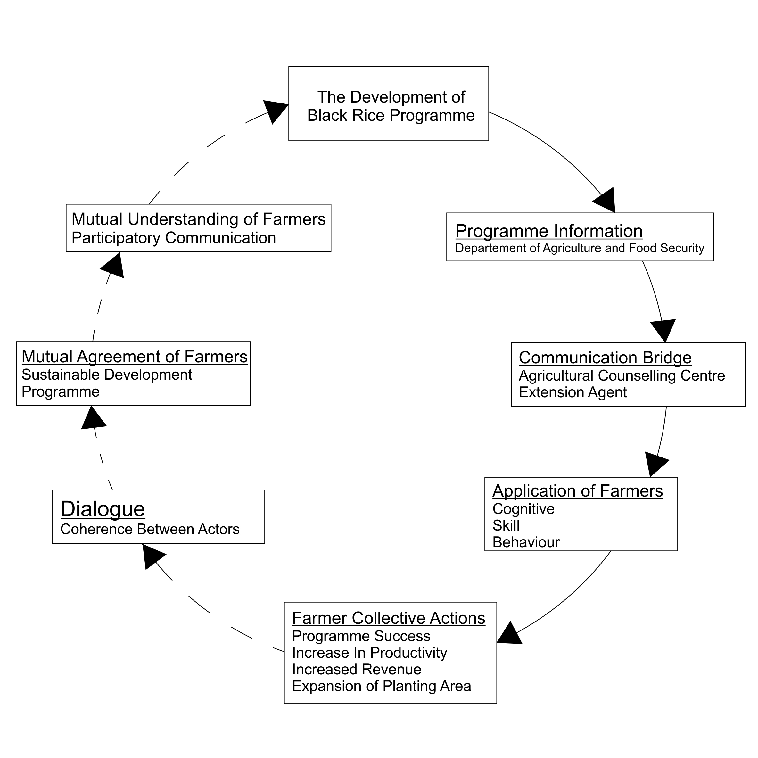

Figure 2 : Convergence communication in the development of black rice programme

The mission of programme development is to conserve black rice so that it does not become extinct, improve the welfare of the community, empower the people and reduce the unemployment rate. It is very important to inform all actors involved in the development of black rice programme. If the level of farmer participation to join the programme increases, there is cooperation between all of actors, therefore more people will get benefits from the development of black rice programme. Expansion of the planting area is needed to increase productivity so that the availability of black rice stocks is always maintained throughout the year, so that it can be an excellent product in the area parallel with shallots and salted eggs.
The implementation of the development of black rice programme cannot be generalized in every region, because it must be adapted to the situation of the community (Moyo and Salawu, 2018) and the local natural conditions (Budiman and Arisoesilaningsih, 2015). Black rice has a very specific character and so far it can only be cultivated in seven villages in Sirampog sub-district which has a height of around 900 meters above sea level. The development outside the region cannot be carried out because of the very strong protection of black rice seeds by community so that it is not allowed to be developed outside the area.

Conclusion and Recommendations
An effective communication strategy in the development of black rice farming programme is participatory communication, by maximizing the role of Agricultural Extension Centre as a communication bridge in the delivering programme information from Department of Agriculture and Food Security to farmers.
The government should continue the development of black rice programmes to conserve black rice, increase the productivity, through designing policies that support programme development. In our future work, we intend to develop communication convergence to measure the effectiveness of agricultural development programmes in order to run sustainable.

Acknowledgements
The authors would like to thank the SEAMEO (Science and Education for Agriculture and Development), SEARCA (Southeast Asian Regional Centre for Graduate Study and Research in Agriculture) for financial support.
References
Aka, K. G. (2019). Actor-network theory to understand, track and succeed in a sustainable innovation development process. Journal of Cleaner Production, 225: 524–540. doi : 10.1016/j.jclepro.2019.03.351.
Alves, G. H., Ferreira, C. D., Vivian, P. G., Monks, J. L. F., Elias, M. C., Vanier, N. L., & de Oliveira, M. (2016).The revisited levels of free and bound phenolics in rice: Effects of the extraction procedure. Food Chemistry, 208: 116–123. doi : 10.1016/j.foodchem.2016.03.107.
Bae S. O., & Chung D. O. (2015) Quality characteristics of tea-bags processed with black rice and black rice bran. Korean Journal Food Science of Animal Resources, 21:85–90. doi : 10.5851/kosfa.2017.37.4.552.
Budiman, & Arisoesilaningsih E. (2015). An Interaction model between environmental factors and black rice growth in irrigated organic paddy field. AGRIVITA, 37(1): 30-36.
Department of Agriculture and Food Security. (2015). Determination of the Team for the Development of Black Rice in the Extension Activities for Alternative Food Sources in Brebes District. Brebes, Indonesia.
Eriyanto. (2014). Communication network analysis. Jakarta: Indonesia, Prenadamedia Group.
Feiock, R. C. (2013). The institutional collective action framework. Policy Studies Journal, 41(3): 397– 425. doi : 10.1111/psj.12023.
Hayran, S., Gul, A., & Saridas MA. (2018). Farmers’ sustainable agriculture perception in Turkey: The case of Mersin province. Mediterranean Journal of Economics, Agriculture and Environment, 3: 69-78. doi : 10.30682/nm1803f.
Hwang, S.-N., Kim, J. C., Bhuiyan, M. I. H., Kim, J. Y., Yang, J. S., Yoon, S. H.,Yoon SH., Yoon KD., & Kim, S. Y. (2018). Black Rice (Oryza sativa L., Poaceae) Extract reduces hippocampal neuronal cell death induced by transient global cerebral ischemia in Mice. Experimental Neurobiology, 27(2): 129 -138. doi : 10.5607/en.2018.27.2.129
Joo, S. Y., & Choi H. Y. (2013). Antioxidant activity and quality characteristics of black rice bran cookies. Journal of the Korean Society of Food Science and Nutrition, 41:182–191. Doi : 10.3746/jkfn.2012.41.2.182.
Lewis, S. (2015). Qualitative inquiry and research design: Choosing among five approaches. Health Promotion Practice, 16(4): 473–475. doi : 10.1177/1524839915580941.
Manson, S. M., Jordan, N. R., Nelson, K. C., & Brummel, R. F. (2016). Modeling the effect of social networks on adoption of multifunctional agriculture. Environmental Modelling & Software, 75: 388–401. doi : 10.1016/j.envsoft.2014.09.015.
Meng, L., Zhang, W., Wu, Z., Hui, A., Gao, H., Chen, P., & He, Y. (2018). Effect of pressure-soaking treatments on texture and retrogradation properties of black rice. LWT, 93: 485–490. doi : 10.1016/j.lwt.2018.03.079.
Moyo, R., & Salawu, A. (2018). A survey of communication effectiveness by agricultural extension in the Gweru district of Zimbabwe. Journal of Rural Studies, 60: 32–42. doi : 10.1016/j.jrurstud.2018.03.002.
Patterson, J. (2017). Purposeful collective action in ambiguous and contested situations: exploring ‘enabling capacities’ and cross-level interplay. International Journal of the Commons, 11(1) : 248–274. doi : 10.18352/ijc.696.
Patterson, P. D., Pfeiffer, A. J., Weaver, M. D., Krackhardt, D., Arnold, R. M., Yealy, D. M., & Lave, J. R. (2013). Network analysis of team communication in a busy emergency department. BMC Health Services Research, 13(109): 1-12. doi: 10.1186/1472-6963-13-109.
Pratiwi, R., & Purwestri, Y.A. (2017). Black rice as a functional food in Indonesia. Functional Foods in Health and Disease, 7(3): 182-194.
Shao, Y., Hu, Z., Yu, Y., Mou, R., Zhu, Z., & Beta, T. (2018). Phenolic acids, anthocyanins, proanthocyanidins, antioxidant activity, minerals and their correlations in non-pigmented, red, and black rice. Food Chemistry, 239: 733–741. doi: 10.1016/j.foodchem.2017.07.009.
Shin, H.-Y., Kim, S.-M., Lee, J. H., & Lim, S.-T. (2019). Solid-state fermentation of black rice bran with Aspergillus awamori and Aspergillus oryzae: Effects on phenolic acid composition and antioxidant activity of bran extracts. Food Chemistry, 272: 235–241. Doi: 10.1016/j.foodchem.2018.07.174.
Toral-Cruz, H., Mihovska, A. D., Gaj, P., He, D., Ramírez-Pacheco, J. C., Voznak, M., & Lokshina, I. (2017). Advances and challenges in convergent communication networks. Wireless Personal Communications, 96(4): 4919–4927. doi : 10.1007/s11277-017-4964-y.
Williams, M. J., & Musolesi, M. (2016). Spatio-temporal networks: reachability, centrality and robustness. Royal Society Open Science, 3(6): 160- 196. doi: 10.1098/rsos.160196.
Zulfiningrum, R., & Yusriana A. (2018). Network and e-commerce net generation: vlogging. Jurnal Avant Garde, 6(2): 1-19.

